 | DEPARTMENT OF  MATHEMATICS, FSM UNIVERSITY DIPONGORO | DOCUMENT LEVEL:  PROCEDURE MANUAL | CODE: MP.MA-07
TITLE: | ASSESSMENT OF LEARNING PROCESS |  | ISSUED DATE:  February 19, 2010
AREAS : | ACADEMIC FIELD |  | REVISION Number:-

PROCEDURE MANUAL ASSESSMENT OF LEARNING PROCESS

AIMS
MP Learning Outcomes Assessment aims to provide guidance to course lecturers regarding the procedure for assessing student learning outcomes of FSM Diponegoro University in certain subjects objectively and transparently

DEFINITION
One of the main tasks of the lecturer is to carry out an assessment of learning outcomes and submit the evaluation results to the Faculty Academic Section according to the schedule, after the test materials for students are arranged according to the learning objectives and are valid. Assessment of student learning activities and progress is carried out throughout the learning process and periodically which can take the form of exams, task execution and observations, as follows:
- The exam is basically carried out in the form of a written exam consisting of a midterm exam, a semester final exam
- Structured tasks
- Based on certain reasons that can be justified, the assessment of learning outcomes can be done in other forms.

REFERENCE
- Decree of the Minister of National Education Number 232/U/2000 concerning Guidelines for Preparation of Higher Education Curriculum and Assessment of Student Learning Outcomes
- Decree of the Minister of National Education Number 045/U/2002 concerning the Core Curriculum of Higher Education
- Rector's Regulation no. 364/PER/H7/2009 concerning Academic Regulations for Undergraduate and Diploma (III)/IV) Education at Diponegoro University

PROCEDURE
1. The lecturer/teaching team determines the assessment instrument which includes formative and summative tests according to the character of the courses taught and stated in the course RPS, and course contracts.
- Lecturers/teaching teams compile assessment materials by synchronizing time allocation and assessment period. Assessment materials must be prepared taking into account the principles of andragogy (adult education), and teaching techniques.
- Lecturers/teaching teams assess students (during the process) or are scheduled by the faculty in mid and/or final exams.
- Lecturer/teaching team corrects/marks and evaluates students work
- The lecturer/teaching team recapitulates all assessment instruments during the lecture by considering the course RPS (Semester Learning Plan)t that has been determined before the lecture (the portion of each component is according to the lecture contract)
- Lecturer/teaching team analyzes student score data by synchronizing the predetermined scoring system
- The lecturer/teaching team announces the list of students who get a D grade before the 7th day after the final exam for the course, and the remedial schedule according to faculty rules
- Lecturers/teaching teams retest and assess students with D . scores
- The lecturer/teaching team determines the student's temporary quality score in A, B, C, D, or E
- The lecturer/teaching team evaluates the distribution of temporary scores by considering the feasibility of the distribution to describe and differentiate the abilities of each student at their respective levels (eg the principle of a normal distribution).
- Lecturer/teaching team hears the results of the interim assessment in the team's internal meeting and/or the department's prayudisium as permanent value
- The lecturer/teaching team writes the results of the assessment (quality score) on the DPNA as the student's final score
- The lecturer/teaching team writes the value distribution on the value distribution form
- The lecturer/teaching team submits the DPNA to the Faculty Teaching Section. The 4th sheet of DPNA is archived by the examining lecturer
- The Teaching Section announces the final grade of the course, online or posted on the bulletin board

Flow diagram

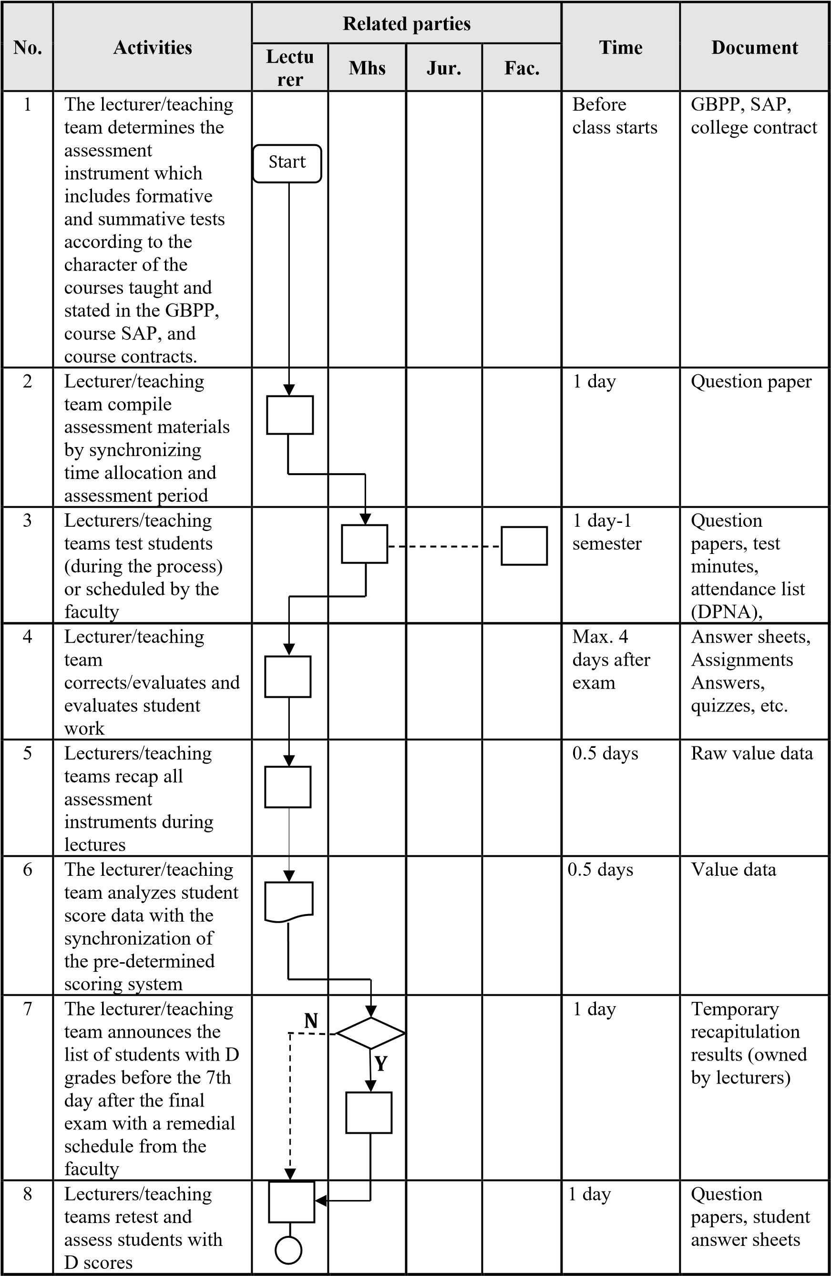

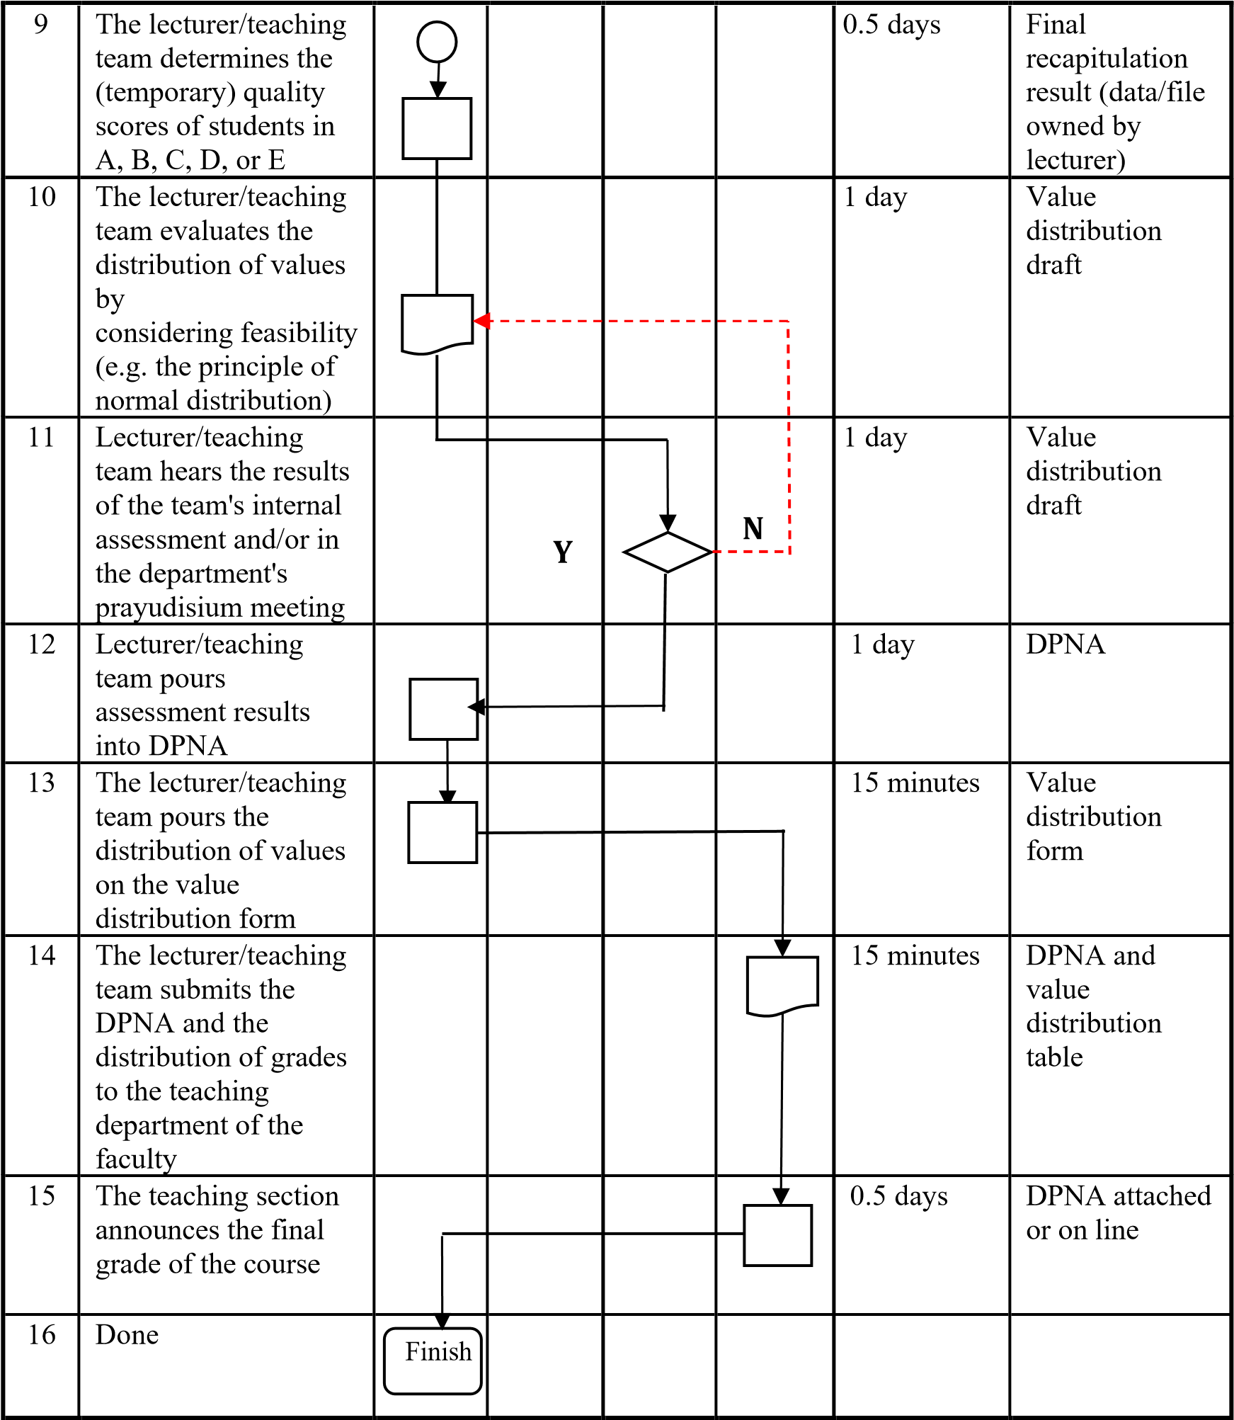

ATTACHMENT I. Terminology

Here are some definitions of terms related to the learning outcomes assessment procedure

- Regular undergraduate (S1) programs are academic education programs after secondary education, which have a study load of at least 144 credits and a maximum of 160 credits which are scheduled for 8 semesters and can be completed in less than 8 semesters and a maximum of 14 semesters.
- Faculty is a structural unit at the University that coordinates and/or carries out education and/or professionals in one or a set of branches of science, technology and/or arts.
- The Department is an academic implementing element in the faculty and as a forum that facilitates the implementation of study programs.
- The study program is a unified study plan as a guideline for the implementation of academic and or professional education which is held on the basis of a curriculum and is intended so that students can master the knowledge, skills and attitudes in accordance with the curriculum objectives.
- Students are students who are registered and studying at Diponegoro University.
- DPNA is a list of lecture participants and final grades containing students who take courses and grades that will be announced to students
- Lecturers are educators at higher education who are specially appointed with the main task of teaching. Lecturers consist of permanent lecturers and nonpermanent lecturers.
- The lecture contract is one of the main tasks of the lecturer to know the students before the lecture/at the beginning of the lecture which must be socialized to the lecture participants so that all students know from the beginning what will be studied and what must be prepared.
- The assessment system is also an administrative system which is the main task of lecturers in providing evaluations and awards for student achievements in related subjects.
- GBPP and SAP are global guides for lecturers on methods, materials and lecture plans, time allocation and systems, lectures that will be conducted by lecturers
- The PAP scoring system is a Benchmark Reference Assessment system
- The PAN scoring system is a Norm Reference Assessment system

II. Semester Exam Requirements:
- Registered as a participant in the course concerned, namely those listed in the List of Lecturers (DPK)
- Have attended the relevant courses at least 75% in the current semester.

Scoring system
Scoring system
- The type and method of conducting the assessment is adjusted to the nature of the course.
- The value of learning outcomes is expressed by letters and weight values as follows:
A = 4;
  - = 3;
  - = 2;
  - = 1; E = 0.
- Grades D and E are considered not to pass, for grades D are required to make improvements with repeated exams, for grades E are required to repeat the learning program and exams.
- Students who get grades B and C are given the opportunity to improve their grades and at the end of the program they use the best grades.
- The test scores are announced publicly.
- Students are allowed to improve their test scores in other semesters.
g. If for some reason the value has not been determined, then the student is given a TL score which means it is incomplete with a zero weight value (0).

How to assess

Assessment can be carried out using a combination approach to Benchmark Reference Assessment (PAP) and Norm Reference Assessment (PAN). The combined assessment of Benchmark Reference Assessment (PAP) and Norm Reference Assessment (PAN) is carried out by applying the following Teaching and Learning Process (PBM) activities:
- General Instructional Objectives (TIU)/Standards of Competence and Specific Instructional Objectives (ICT)/Basic Competencies have been formulated properly and correctly;
- General Instructional Objectives (TIU)/Standards of Competence and Specific Instructional Objectives (ICT)/Basic Competencies are communicated to groups of lecturers and students;
- Conducted evaluation throughout the semester (continuous assessment);
- Motivated efforts were made on the part of the students;
- Enrichment efforts are made in lectures;
- An evaluation of the achievements of TIU and ICT is carried out.
Lecturers are required to use a combination of LAP and PAN approaches.

The parties involved in the assessment of learning outcomes
- Lecturer c. Major
- College student d. Faculty Teaching Section

Documents Related to Assessment of Learning Outcomes
- Silver d. Question paper
- DPNA e. Value distribution form
- GBPP, SAP

